Columbia County Traffic Control Devices Standard Locations
Standards are based on the Federal Highway Administration's
Manual on Uniform Traffic Control Devices, 2003 edition

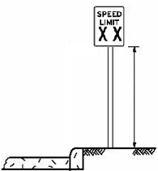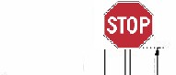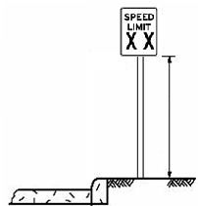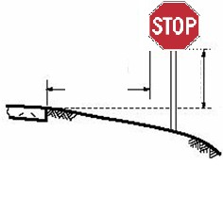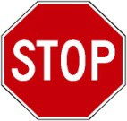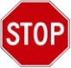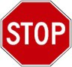B
Minimum 12
inches. h
b
t
Minimum 6 feet
Minimum 7 ft. eight from ottom of sign o ground.
Minimum 7 ft. height from
Minimum 12 inches.
Minimum 6 feet.
Minimum 7 ft. height from bottom of sign to projected roadway. surface.
Minimum 7 ft. height from bottom of sign to ground.
A
** Typically place stop / street name sign at the beginning of the radius.
However, if the stop sign needs to be placed in the radius to increase the visibility of the street name sign, use the following diagram as a guide.
Stop / street name sign placement
in the radius.
A
B
A
B
C
Mount on separate posts, if necessary.

A: May vary, but MAXIMUM distance is 50 feet and MINIMUM distance is 6 feet from travelway, for a Stop Sign.
B: For curb (≥6") & gutter streets, lateral offset to edge of sign should be minimum of 12 inches from face of curb. For all other streets (ditch, raised edge, rolled curb, etc.), lateral offset to edge of sign should be a minimum of 2 feet from edge of pavement/curb for ≤ 25 MPH and lateral offset to edge of sign should be a minumum of six feet for speeds > 25 MPH.
C: Distance will vary based on best location, but should never exceed six feet from projected edge of pavement extended and still meet condition B, if street markers not visible for main street after determining best location for Stop Sign, mount markers on seperate post.
Every effort should be made to reduce foliage in the intersection ROW so that the typical stop sign placement may be achieved.

Minimum of 4 ft from travelway.
Columbia County Traffic Control Devices Standard Locations
Standards are based on the Federal Highway Administration's
Manual on Uniform Traffic Control Devices, 2003 edition
from travelway.
A
Stop Bars should be a minimum of four from the travel way.
The speed limit is generally the first sign. Other first signs may require different spacing as |  | B |  |  |  |  | Stop bars should be placed to allow sufficient sight distance to see traffic on other approaches to an intersection.  The stop bar does not have to be at th Stop Sign location.  Stop Bars should be 12 to 24 inches in width (local road to local road intersectio
use 12", any combo of local road to
collector road and/or arterial road, use 24
Stop Bar length should run from projecte
The second sign centerline to the edge of pavement or
may be any type of gutter.
traffic control

A: Typical range of spacing between the first sign
SPACING BETWEEN SIGNS (typically speed limit) and the end of the radius.
Speed Limit of  Road (MPH) |  | Distance Between Signs |  |  |  |  | B: Desirable minimum spacing between signs.
Speed Limit of  Road (MPH) | A |  |  |  |  | B
25 | 100 to 175 |  |  |  |  | 125 | Columbia County reserves the right to require
30 | 125 to 225 |  |  |  |  | 150 | additional signing, such as Stop Ahead, Curve
35 | 200 to 300 |  |  |  |  | 175 Left, Cross Road, etc. as determined at the time
40 | 300 to 400 |  |  |  |  | 250 | plan review or final platting.
45 | 325 to 450 |  |  |  |  | 300
50 | 350 to 500 |  |  |  |  | 350 | Any other applicable sign installations should
55 | 400 to 550 |  |  |  |  | 400 conform to the standards & requirements of the
60 | 450 to 600 |  |  |  |  | 450 | Uniform Traffic Control Devices, 2003 edition.
65 | 500 to 650 |  |  |  |  | 500

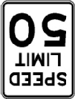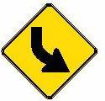feet
Stop Bars should be a minimum of four feet from the travel way.
Stop bars should be placed to allow sufficient sight distance to see traffic on all other approaches to an intersection.
The stop bar does not have to be at the Stop Sign location.
Stop Bars should be 12 to 24 inches in

all

e

n

").
d

of

